Date: 25/09/25
Roll No. and Name: 24BCE173 and Vani Malavia
Course Code and Name: 2CS502CC25 and Object Oriented Programming
Practical No: 7(a)
Aim: Create a class 'Complex' and overload '+' to add two complex numbers.
Methodology followed:
#include <iostream>
using namespace std;

class Complex {
int real, imag;
public:
Complex(int r=0, int i=0) : real(r), imag(i) {}
Complex operator+(const Complex& c) {
return Complex(real + c.real, imag + c.imag);
}
void display() {
cout << real << " + " << imag << "i" << endl;
}
};

int main() {
Complex c1(2, 3), c2(4, 5);
Complex c3 = c1 + c2;
c3.display();
}
Output:
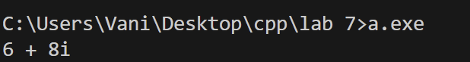
Practical No: 7(b)
Aim: Develop a class 'String' and overload '==' to compare if two string objects are equal.
Methodology followed:
#include <iostream>
#include <cstring>
using namespace std;

class String {
char str[100];
public:
String(const char* s="") { strcpy(str, s); }
bool operator==(const String& s) {
return strcmp(str, s.str) == 0;
}
};

int main() {
String s1("hello"), s2("hello"), s3("world");
cout << (s1 == s2) << endl;
cout << (s1 == s3) << endl;
}
Output:
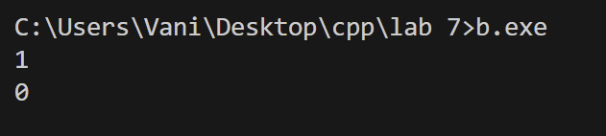
Practical No: 7(c)
Aim: Overload '<<' and '>>' operators in a class 'Person' for customized input and output.
Methodology followed:
#include <iostream>
using namespace std;

class Person {
string name;
int age;
public:
friend decltype(cin)& operator>>(decltype(cin)& in, Person& p) {
cout << "Enter name and age: ";
in >> p.name >> p.age;
return in;
}
friend decltype(cout)& operator<<(decltype(cout)& out, const Person& p) {
out << "Person: " << p.name << " " << p.age;
return out;
}
};

int main() {
Person p;
cin >> p;
cout << p;
}
Output:
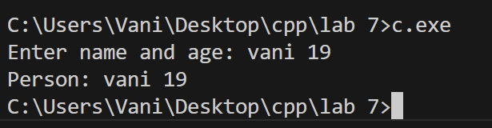
Conclusion:
Through these programs, I learned how operator overloading enhances the usability of classes by enabling natural operations on user-defined types. Overloading +, ==, and stream operators simplified handling of complex numbers, string comparison, and customized input/output, making code more intuitive, readable, and closer to real-world usage.

